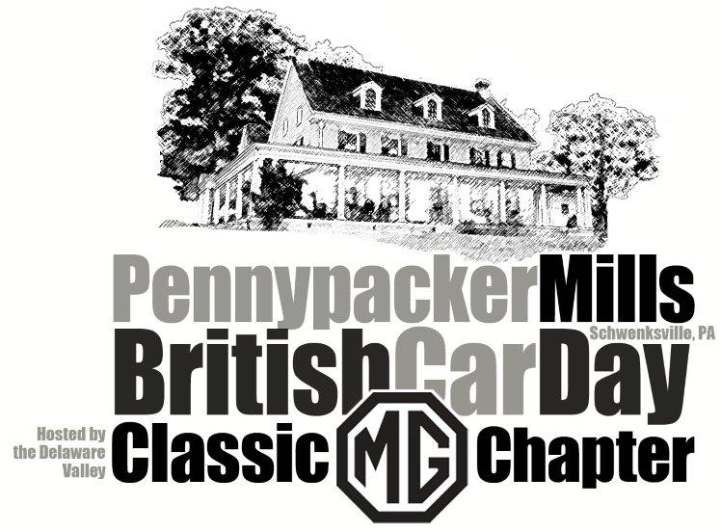

Join us as we celebrate our 50th Anniversary!

Saturday, September 25th 2021
(Rain or shine)

CAR SHOW PRE-REGISTRATION FORM

Name: _______________________________ Email: _______________________

Address: _______________________________ Club Affiliation: ______________

City: ____________________ State: __________ Zip Code: _________________

Car: _______________ Model: _______________ Year: _____ Color: __________

(Need trailer parking space? Yes ___ No ___)

Pre-registration by 9/15/2021 gets you to a $5 discount on the ‘day of show’ price

($15 instead of the $20 gate price)

Send check and completed form to: Nancy Yaskowski, 517 Quarry Road, Spring City, PA 19475
Additional information: www.DVCMG.com or call Paul Phillips 610-792-1158

Release: Neither my heirs nor I will hold the Delaware Valley Classic MG Chapter, any of its members, or show staff liable for any personal injuries or damages sustained by me, my party, or my car while traveling to and from this event, and while participating in this event.

Signature: _______________________________________________ Date: ____________________

